

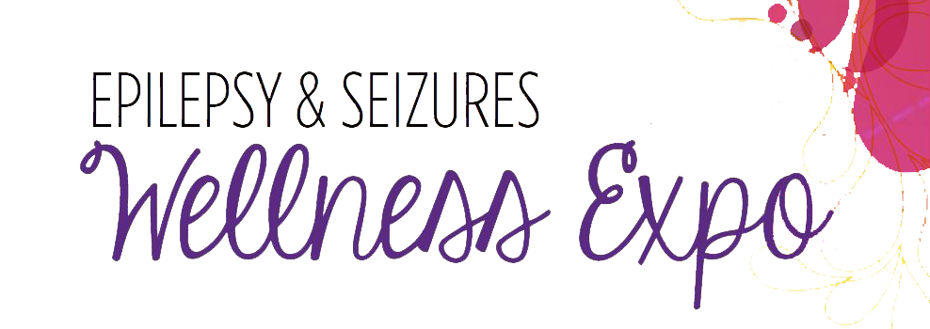

**Join Us!**

***What?*** First-ever expo with expert speakers, wellness exhibitors and customized resources to help people rise above seizures!

***When?*** Saturday, April 16 from 9 AM – 3 PM

***Where?*** Minneapolis Convention Center

Bring your friends and family to get connected to

custom resources and other people who rise above seizures.

**We will be there – check out our booth!**

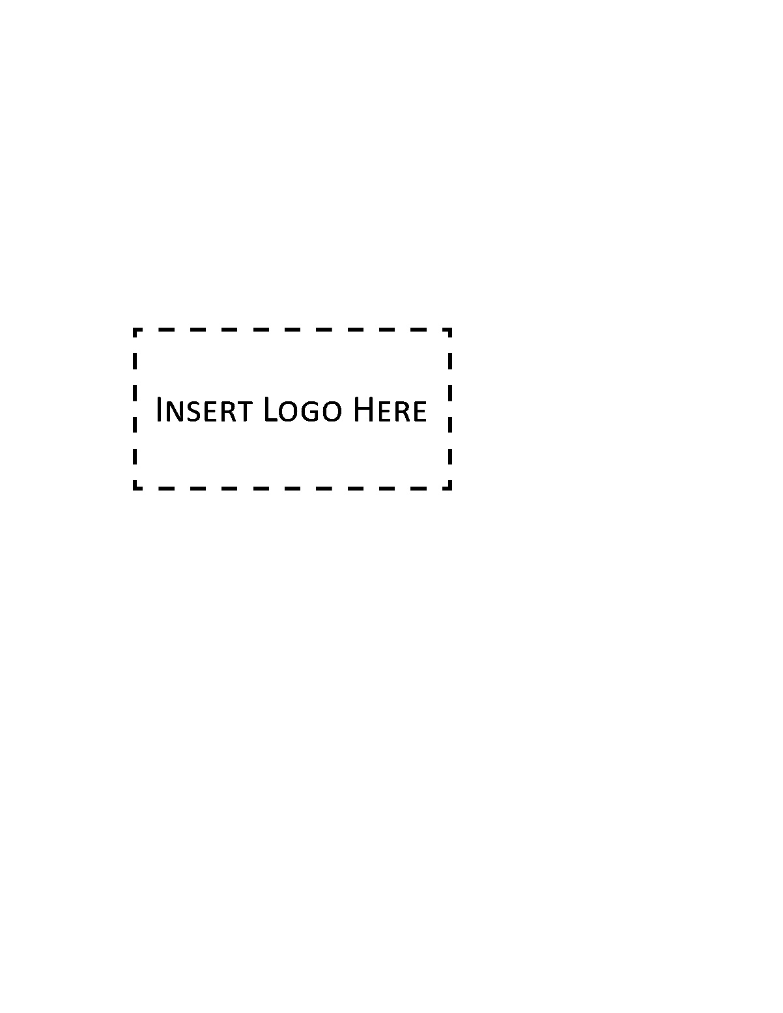

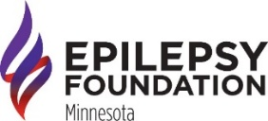Register at **efmn.org** or call **800.779.0777**.