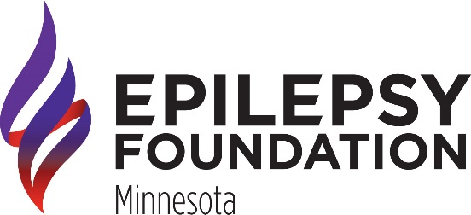
RISE ABOVE SEIZURES WALK: INDIVIDUAL & TEAM CAPTAIN PACKET

THANK YOU for being a Team Captain!

Included in your Captain’s Packet, you will find tools to build a successful team along with important walk information. As a Team Captain, your goals are to recruit your friends, family, and co-workers to join your team and fundraise together!

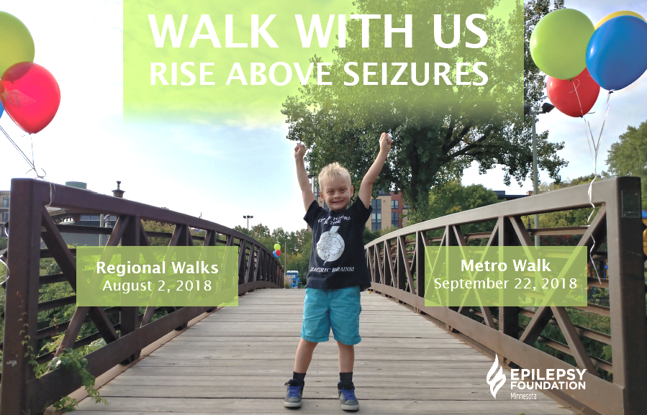

For walk questions | Email: walk@efmn.org
RISE ABOVE SEIZURES WALK: EVENT DETAILS

WHEN? | Thursday, August 2, 2018 |  |  | Saturday, September 22, 2018
WHEN? | Fargo | Duluth | Rochester | St. Cloud |  |  | Twin Cities
WHERE? | All walks are approximately 1 mile in length. Routes are on paved and even paths and walkers are encouraged to walk at their own pace.
 | Fargo | Scheels Arena |  | Twin Cities | Wolfe Park
 | Duluth | Park Point Pavilion |  | Twin Cities | Wolfe Park
 | Rochester | Eagles Club |  | Twin Cities | Wolfe Park
 | St. Cloud | Lake George |  | Twin Cities | Wolfe Park
WHY? | The Rise Above Seizures walks raise awareness and funds to support services for the 150,000+ people EFMN serves annually.
WHO? | Over 3,500 walkers in five communities will come together as a powerful force to help people with epilepsy realize their full potential and STOP seizures.
HOW? | Teams are the foundation of our fundraising efforts. Along with friends and family, many corporate and community groups participate, as well!
GET IN TOUCH!
walk@efmn.org |  |  | 651.287.2330
Epilepsy Foundation of Minnesota - 1600 University Ave W Suite 300, St. Paul, MN 55104
www.efmn.org/walk

RISE ABOVE SEIZURES WALK: MEET YOUR OUTREACH COORDINATOR

FARGO |  |  | DULUTH
 |  |  | 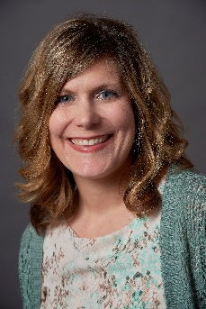
Janice Tweet  jtweet@efmn.org  701.429.1165 |  |  | Lisa Peterson  lpeterson@efmn.org  218.624.1330
ROCHESTER |  |  | ST. CLOUD
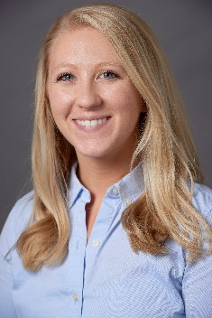 |  |  | 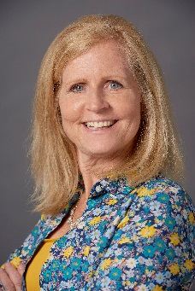
Emily Gomez  egomez@efmn.org  507.287.2103 |  |  | Lori Braegelmann  lbraegelmann@efmn.org  320.203.9722
 |  | TWIN CITIES
 |  | 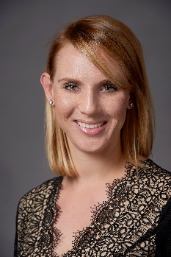
Keri Olufson
Development Officer
kolufson@efmn.org
651.287.2330

RISE ABOVE SEIZURES WALK: FREQUENTLY ASKED QUESTIONS

GETTING STARTED
WHAT IS THE EPILEPSY FOUNDATION OF MN? |  | WHAT IS THE RISE ABOVE SEIZURES WALK?
Founded in 1954, Epilepsy Foundation of Minnesota is a non-profit organization that offers programs and services to educate, connect and empower people affected by seizures. Our mission: the Epilepsy Foundation of Minnesota leads the fight to overcome the challenges of living with epilepsy and to accelerate therapies to stop seizures, find cures and save lives. Our vision is a world where people with seizures realize their full potential. Visit efmn.org |  | The Rise Above Seizures Walk celebrates people with seizures, and raises awareness and funds to support services for the 185,000 people EFMN serves annually. Over 3,500 walkers in five communities come together as a powerful force to help people with epilepsy realize their full potential and stop seizures.  One in 10 people will have a seizure in their lifetime, and one in 26 will develop epilepsy. Everyday people rise above seizures and we applaud that! YOU CAN HELP! The Rise Above Seizures Walk is a chance to celebrate our connections to epilepsy, while raising vital funds to support resources and services that help 185,000 people annually.  IS THERE A REGISTRATION FEE?  No! Each walk is free for all to attend. Also, the Rise Above Seizures Walk does not require walkers to raise a minimum amount of money. However, we encourage everyone to set a fundraising goal and do their best to achieve it. RAS Walk fundraisers are eligible for several appreciation awards.  DO I HAVE TO FORM A TEAM?  You have the option to form a team or participate as an individual. Need help registering? Check out our step by step directions HERE.
HOW ARE MY DONATIONS USED?
Donations support the 60,000 people with epilepsy right here in our community. Thanks to your generosity and dedication, EFMN is able to serve over 185,000 people annually through programs such as:
- Educate Programs:
Seizure Smart Communities, Seizure Response trainings, Conferences & workshops, Information & Referral, Seizure Smart Schools
- Connect Programs:
Camp Oz, Shining Star program, Peer support programs, Family events
- ​Empower Programs:
Advocacy, Creative Arts program, Rise Above Seizures Walk, Volunteering
HOW DO I REACTIVATE MY TEAM FROM 2017? |  | DOES EVERYONE ON MY TEAM NEED TO REGISTER?
*fill in once we decide 2018 website decisions |  | We encourage everyone who is 18+ to register, but it is not required.  WHAT ARE GRAND CLUB TEAMS?  This club celebrates teams who raise $1,000 or more for EFMN’s programs and services. Grand Club members receive special recognition at your team’s regional walk!

RISE ABOVE SEIZURES WALK: FREQUENTLY ASKED QUESTIONS

WALK DAY
HOW CAN I BUILD TEAM SPIRIT? |  | HOW CAN I CONNECT WITH OTHER TEAMS?
We love team spirit! Ordering custom t-shirts can be a great way to recognize why you walk, and can also work as a fundraiser! Check out our local t-shirt partner, Underground Printing, who partners with Custom Ink to get started! Make a team sign to hold proudly during the walk and help your teammates find you on walk day. Dressing up in a team color is another great way to make a statement! |  | FREE awareness bracelets will be available on-site to identify your connection to epilepsy and easily spot others on a similar journey. These connections are important and tell a story. Each walk will have mission connect areas based on your connection to help you meet others! Contact walk@efmn.org if you’d like help in connecting with other teams in your community.
CAN A BUSINESS, CLINIC, NONPROFIT EXHIBIT AT EVENT? |  | IS THERE FOOD AT THE WALK?
Yes! Each location has exhibit & visibility opportunities. Contact Keri at kolufson@efmn.org for information. |  | All locations offer snacks and water.
ARE PETS, STROLLERS etc. ALLOWED AT WALK? |  | WHAT ARE MATCHING GIFTS?
Yes! Each location offers a path that is friendly for strollers, wheelchairs, dogs, etc. Please be sure to clean up after your animals. Email walk@efmn.org if you have questions about a specific location. |  | Matching gift programs are established by many companies with the intention of supporting nonprofit organizations by matching contributions made by their employees. To see if your company offers this program check out our site www.efmn.org/giving.
FUNDRAISING
DO YOU HAVE TOOLS TO HELP ME FUNDRAISE? |  | ARE DONATIONS TAX-DEDUCTIBLE?
Absolutely! From pre-written emails to tips on telling your story, we’re beside you every step of the way. Check out our online fundraising resources, watch for emails from EFMN and connect with other teams to grow your impact. Contact Keri at kolufson@efmn.org for additional assistance with fundraising and hitting your goals! The best thing you can do is ask – you never know who may be willing to support your team. |  | Yes! All donations to EFMN are eligible for a charitable gift tax-deduction. EFMN is a 501c3 nonprofit (tax id: 41-0874541). After making your donation, EFMN will send each donor an acknowledgement letter, which includes a charitable gift tax receipt.​ In addition, anyone who donates $100 or more will receive a limited edition window cling showing their support for people with seizures.
WHO CAN I CONTACT IF I HAVE OTHER QUESTIONS?
We’re happy to hear from you! Contact walk@efmn.org or 651.287.2330

RISE ABOVE SEIZURES WALK: TEAM CAPTAIN CHECKLIST

☐ SIGN UP: | Reactivate or register individually or as a team for the RAS Walk at www.efmn./org/walk. You are welcome to have as many or as few members on your team.
☐ SET GOALS: | Set an example for your team and set your team goal. This goal is decided by you and can be changed at any time.
☐ GET PERSONAL: | Sharing why you walk is one of the main reasons why people decide to give. Customize your fundraising web page with a personal message and photo.
☐ SHOW IT OFF: | Think of a team name and consider ordering or making your own custom team shirt to wear on walk day. Creative and personal names are always best!
☐ BE A TEAM: | Ask your team members to help you motivate, promote, and build your team. If you are walking individually, see our tips and tools on sharing your story on social media.
☐ SHARE: | Sign up friends, family, and coworkers to your team. Ask them to recruit at least one other person!
☐ SET A DATE: | Organize a DIY fundraiser to help raise money for your team. Check out www.efmn.org/giving for ideas on how to create your own.
☐ GET READY: | Be on the lookout for an email from EFMN with important day of walk details and share with your team.
☐ LET’S WALK: | See you on walk day with your team. Don’t forget to get your team photo taken!
☐ SHOW SOME LOVE: | Thank all of your donors and team members for their hard work, dedication, and support.

RISE ABOVE SEIZURES WALK: LET’S FUNDRAISE!

Share your passion and excitement with your network as you work to reach your fundraising goal. There are many ways you can raise funds individually or as a team. Some tested tips and examples of how to fundraise successfully are listed below. Don’t be afraid to think creatively.
LEAN ON YOUR TEAM | You do not have to be the only one raising funds for your team, rally your friends, family, and teammates to help you spread the word and ask for support.
HOLD A DIY FUNDRAISER | This is a great way to get the word out about why you walk and raise funds for your team at the same time. Check out www.efmn.org/giving for examples and steps to set up your personal fundraising event.
ASK ONE PERSON A DAY | Directly asking people to support your team does not have to be intimidating. Share your story about why you walk and what their support will do. No worries if they say no, you are asking from a good place.
AWARENESS AT WORK | Spread the word about your team and why you walk at work. Have a table with information about your team, why you are walking, what is epilepsy, and have your donation envelope available.
DON’T FORGET THE MATCH | Find out if your company has a matching gift program. Matching gifts double your donations. You can see if your company has a matching gift program at www.efmn.org/giving
GIFT OF DONATION | At your birthday, holiday, anniversary, or other special occasion – instead of gifts, ask for a donation to your walk team.
TALENTED? | Are you crafty or have a talent to share? Make something to raffle off or donate your time and talent and ask for a donation to your team.
RISE ABOVE SEIZURES WALK: THE EASY ASK

1 | 2 | 3 | 4 | 5
WHAT  IS THE NEED | WHY  IS IT IMPORTANT | WHO  DO YOU WALK FOR | ASK  FOR YOUR NEED | WAIT  & LISTEN

PUT THE 5 ASK STEPS INTO ACTION
EXAMPLE ASK: There are 60,000 Minnesotan’s who have epilepsy – enough to fill TCF Bank Stadium. Epilepsy affects more Americans than multiple sclerosis, cerebral palsy, muscular dystrophy, and Parkinson’s disease combined. My daughter is a part of the 1 in 26 who will develop epilepsy in their lifetime. We participate in the Rise Above Seizures Walk in honor of her and in support the resources and programs that the Epilepsy Foundation of Minnesota provides. EFMN has been by our side from the beginning of her diagnosis. Will you be by our side and support our team by donating $50?

NOW YOU TRY
STEP 1:
WHAT IS THE NEED
STEP 2:
WHY IS THE NEED IMPORTANT
STEP 3:
WHO DO YOU WALK FOR
STEP 4:
ASK FOR WHAT YOU NEED
STEP 5:
WAIT FOR DONOR TO REFLECT & RESOND

RISE ABOVE SEIZURES WALK: USING SOCIAL MEDIA
YOUR TEAM/PERSONAL PAGE | Whether you are a group of many team members or an individual walker sharing your story matters! Let them know why you walk.
GET YOUR MESSAGE OUT | Email friends, family, or coworkers directly from your fundraising page using one of our pre-written emails or write your own.
KEEP IN THE LOOP | Make sure those who are supporting you are kept in the loop as your fundraising journey grows. Don’t forget to let them know walk day details and your post walk total!

THE POWER OF SOCIAL MEDIA
The use of social media is where a majority of us receive our news and stay up to date with friends and family. Take advantage of this platform by sharing your story, your team, and your fundraising goal on social media. When you share your team page on social media it will include a direct link to your page where people can donate to your team. Encourage everyone to like, comment, and share each post you make to reach a larger audience.
 | Ask your Facebook community to like, comment, and share your posts
 | Don’t forget to share a picture of you and your team.
 | Follow and share EFMN’s Facebook page. Ask family and friends to like and follow, as well.
 | Update your profile picture and cover photo to promote your walk team
 | Tweet daily about your team’s progress. Use #riseaboveseizures or #riseaboveseizureswalk
 | Follow EFMN’s Twitter account @EpilepsyMN
 | Retweet walk messages from EFMN
 | LIVE Tweet the day of the walk!
 | Photos are the best way to grab attention. Don’t forget #riseaboveseizures or #riseaboveseizureswalk. Pictures from the day of the walk are a great way to keep those in the loop who supported your team but couldn’t make it to the walk.  EFMN IS NOW ON INSTAGRAM @epilepsyfdnmn

