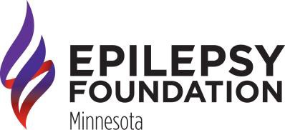

BRAINSTORMS ARTWORK COLLECTION

ELIGIBILITY
Youth and adults diagnosed with epilepsy and/or a seizure disorder.

COLLECTION PARAMETERS
- Original work by contributor
- Maximum of one entry per year
- Maximum dimension of 24” by 36”
- Unframed submissions preferred
- Submit artwork at EFMN or by mail
- Subject matter consistent with good taste

GUIDELINES
- Painting, sketch, sculpture, colored pencil, etc.
- Connection to overcoming obstacles related to epilepsy
- Artist biography information included
- High resolution, recent photo of the author suggested

FRAMING
Brainstorms artwork is framed once a year by a professional artist.

RECOGNITION
- Each artist receives a certificate
- Potential of public appearances
- Invitation to special, Creative Arts events
- Work exhibited throughout the state to raise epilepsy awareness

For more information, please contact Tammy Sammon at 651.287.2304 or tsammon@efmn.org.

