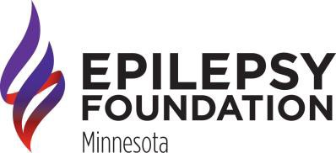

EPILOGUES WRITING COLLECTION

ELIGIBILITY
Youth and adults diagnosed with epilepsy and/or a seizure disorder. Also open to caregivers, family and friends of individuals with epilepsy.

COLLECTION PARAMETERS
- Original work by contributor
- Maximum of three entries per year
- Maximum word count of 2,500
- Typed entries preferred
- Submit work by fax, mail or email
- Subject matter must be able to be shared with both youth and adults

GUIDELINES
- Poetry, essay, short story, letter, etc.
- Connection to overcoming obstacles related to epilepsy
- Author biography information included
- High resolution, recent photo of the author suggested

EDITING
Epilogues is reviewed for consistent style (grammar, punctuation, spelling, etc.) Writers are given an opportunity to see revisions to their work.

RECOGNITION
- Each writer receives a mailed copy of Epilogues and certificate
- Potential of public readings
- Invitation to special, Creative Arts events

For more information, please contact Tammy Sammon at 651.287.2304 or tsammon@efmn.org.

